MILESTONE 1 PROJECT REPORT – DAVID FORKEL
IT4403: ADVANCED WEB AND MOBILE APP

OVERVIEW
Milestone 1 used JavaScript and jQuery to locate and display the necessary book information from the provided JSON files. The first webpage focuses on displaying the information associated with the single book Fantastic Mr. Fox, such as the author, publisher, publication date, ISBN numbers, and any other relevant details. The second webpage displays these elements for a collection of books based on a given search term, then using a loop to organize the books into a section.
Concepts from Lab 3 were apparent in this milestone such as JSON objects, nested structures, and arrays. I added elements that would handle any missing information by displaying specific error text as well as cleaning up the language for readability’s sake.

URLs
Homepage - https://itsforkel.github.io/IT4403/
Milestone 1 - https://itsforkel.github.io/IT4403/projects.html
Single-Book Information - https://itsforkel.github.io/IT4403/Milestone1/milestone1_book_dforkel.html
Book Search Results - https://itsforkel.github.io/IT4403/Milestone1/milestone1_search_dforkel.html

Screenshots
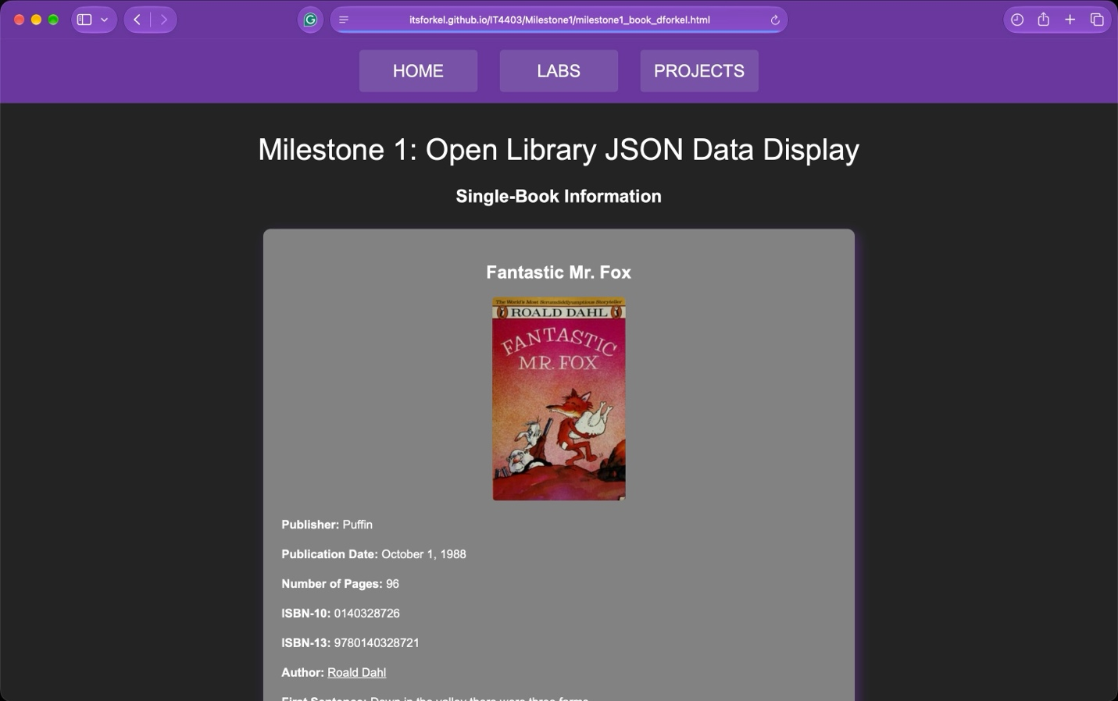
^Screenshot 1: Single Book Page^
This screenshot displays the information retrieved from the book.json file. JavaScript and jQuery are used to display the book title, author, publisher, publication date, ISBN numbers, and other information. The book cover and link to Open Library records are present as well.

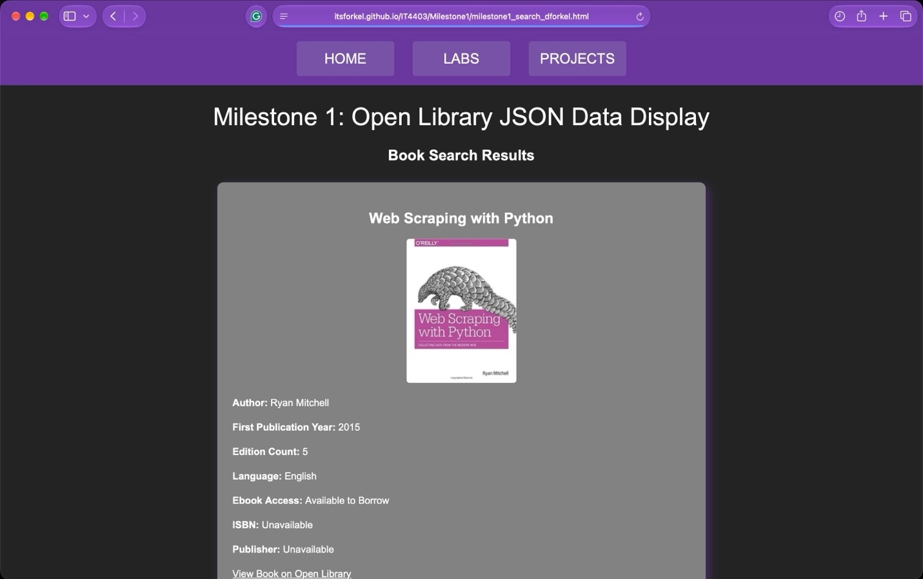^Screenshot 2: Search Results Page^
This screenshot displays the information retrieved from the search.json file. JavaScript and jQuery are used to display the book titles, authors, publication years, edition counts, and other information. A loop is used to organize each book into its own section, with book covers and links to their Open Library records present as well.

How do the JSON files differ?
The JSON files differ in the amount of book information they contained and how the data was organized within each file. The book.json file contained a single book while the search.json contained a collection of books based off the search term “modern web.” The book.json file used objects and name/value pairs as its main information organization method, while the search.json file used a “docs” array to store the many book records, allowing access using a loop.

How my code handles arrays, nested data, and missing values?
My code handles arrays by accessing the information stored within them, also using loops when necessary to display multiple book records/values. Any nested data is accessed through JavaScript to get specific information about objects within the JSON files. Missing values are handled using terms such as “Unavailable” and “Book Information Unavailable” to show missing information and errors with the JSON file.

